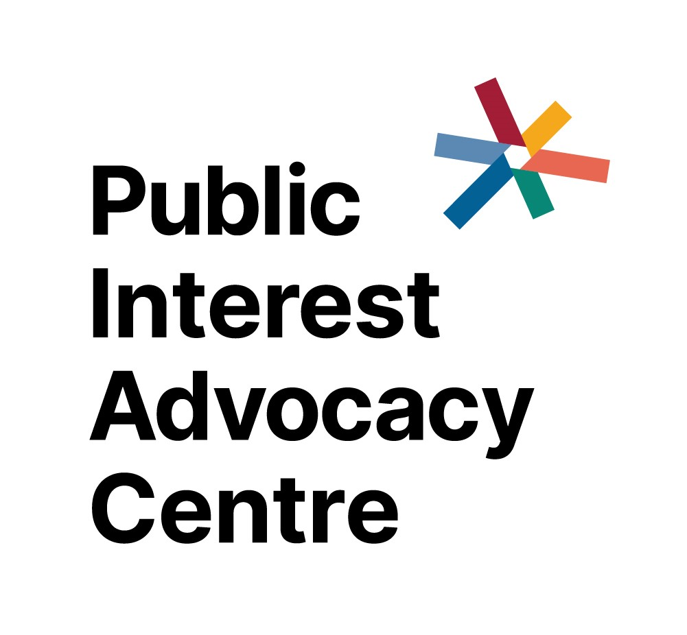

Position Description
Project Director – Towards Truth

Two year fixed contract
Part-time (approximately 3 days, negotiable)
- The Public Interest Advocacy Centre
The Public Interest Advocacy Centre (PIAC) is a leading social justice law and policy centre. We build a fairer, stronger society by helping to change laws, policies and practices that cause injustice and inequality.
Our work combines:
- Legal advice and representation, specialising in test cases and strategic casework;
- Research, analysis and policy development; and
- Advocacy for systems change and public interest outcomes.
We actively seek to collaborate and partner in our work to maximise its impact. Our priorities include reducing homelessness; First Nations justice; climate change and social justice; equality and non-discrimination; asylum seeker health rights; and the fair use of police powers.
- Towards Truth Project
Towards Truth is a collaboration between PIAC and the Indigenous Law Centre (ILC) at UNSW that responds directly to the call of the Uluru Statement from the Heart for truth-telling.

We are building a database and accessible website that will provide an accurate, detailed map of the ways in which Australian laws and policies have impacted upon the lives of First Nations people throughout Australian history.

The truth-telling process called for in the Uluru Statement from the Heart is to be overseen by the Makarrata Commission and will be closely connected with the process of moving towards treaty making. Towards Truth is designed as a tool that can be used by the Makarrata Commission, as well as by a broad cross-section of the community, to engage in truth-telling.

This is a bold and ambitious project that is the first of its kind – nationally or internationally.
- Position overview
The Project Director has responsibility for delivering the Towards Truth project, working with a large team of staff, pro bono lawyers and volunteers. The position reports directly to the CEO.
- Major accountabilities
- Manage the project partnership with the ILC.
- Manage and supervise project staff, including pro bono lawyers and interns.
- Drive the ongoing development of the Towards Truth database including:
  - setting research priorities with the team, consistent with the strategic guidance of the ILC;
  - ensuring accurate research and analysis, including reviewing substantive material where necessary;
  - ensuring research processes are robust, implemented consistently and modified as required;
  - developing relationships with experts to undertake subject reviews.
- Developing and delivering a publicly accessible website.
- With the CEO and Relationships Manager, develop and manage external relationships with funders and pro bono supporters to secure resources for the project including:
  - drafting funding applications, proposals and acquittals;
  - regular contact with project partners to keep them engaged and updated on project progress.
- Deliver and/or participate in training sessions for new researchers and experts where required.
- Represent PIAC externally to promote awareness and understanding of Towards Truth.
- Contribute to the successful implementation of PIAC’s Reconciliation Action Plan.
- Other duties as required.
- Selection criteria
- Tertiary qualifications in law or relevant experience in legal research.
- Strong project management skills, including a demonstrated capacity to achieve outcomes individually and/or in a team environment and to produce quality results on time;
- Understanding of the Uluru Statement from the Heart and a commitment to its realisation;
- Experience working with Aboriginal and Torres Strait Islander people and/ or organisations;
- Excellent writing skills including experience in editing the work of others;
- Well-developed interpersonal skills and the capacity to develop formal and informal relationships and networks in order to engage and build rapport with stakeholders;
- Understanding of the law and functions of government;
- Demonstrated ability to lead a diverse team comprising staff and volunteers.
- Conditions
Annual salary range: $120,602 to $125,341 (pro rata - Level 8 on PIAC’s salary scale) plus leave loading and superannuation. PIAC is a Public Benevolent Institution and is currently able to offer salary packaging subject to PIAC’s Salary Sacrifice Policy.

The position is offered 3 days per week or 22.5 hours per week, with an opportunity to negotiate hours and flexible working arrangements with the successful candidate.

PIAC requires all employees to have up-to-date COVID-19 vaccination.
- Applications
Your application should be no longer than 6 pages in total. An application should comprise a cover letter, resume, and a statement outlining your suitability for the role with reference to the selection criteria (see ‘knowledge, skills and experience’).

Applications should be sent by email to jobs@piac.asn.au

Inquiries about the position should be addressed to:

Jonathon Hunyor
CEO, PIAC
jobs@piac.asn.au

